Chiragkumar solanki

15035

1. Write the program to verify whether white space “Carriage Return” and “Formfeed” in “helloWorld.v” work or not, and show the result.

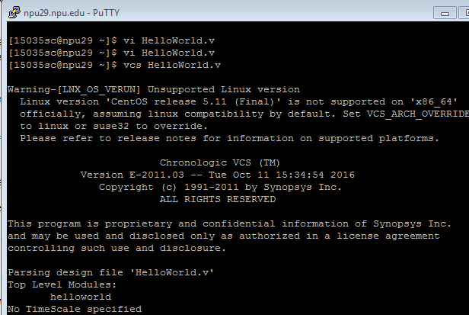

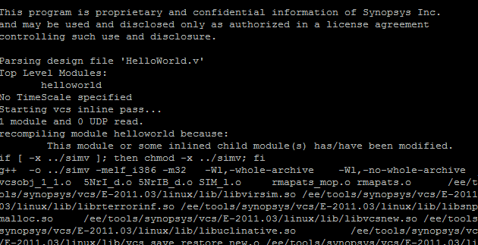

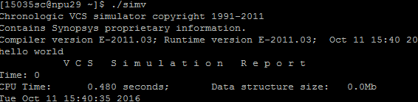

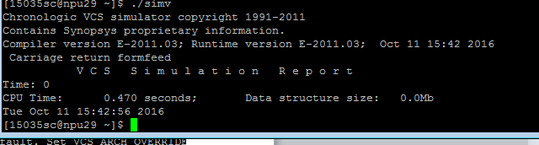

1. If a variable name is defined using a keyword, write a code snippet to look at what will happen and show error/warning information.

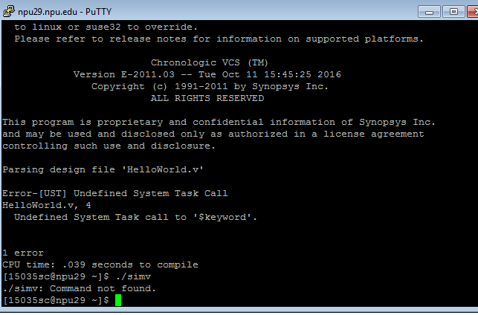

1. When a module name is &$$abc_123, how to make it pass compilation by writing a program to verify?

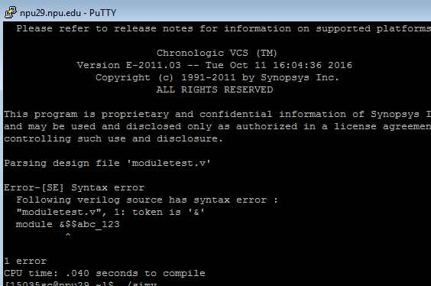

1. Define a variable type “tri”, and make two devices in the same value(e.g. 1, 1) and different value(e.g. z, x) to drive it, what do you get and show running results? Take an example on the handout as reference.

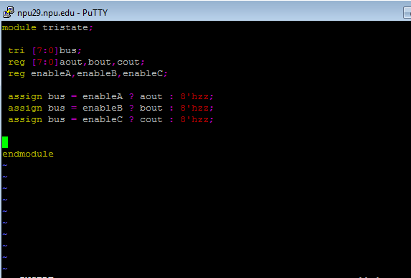

1. 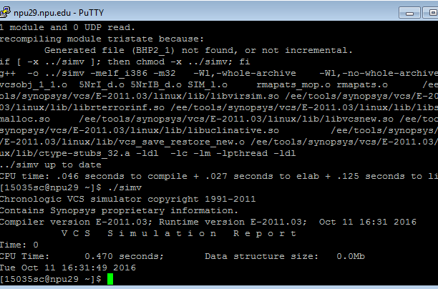

5. Retype “wor/trior ” and “wand/triand” test programs on the handout and assign all 16- combination values to them. Compare the results with the values in truth table. And show results.

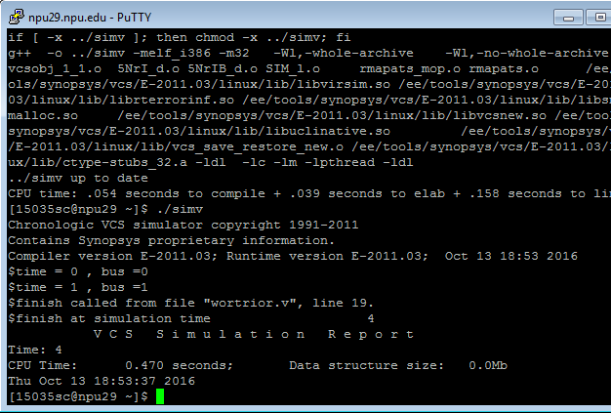

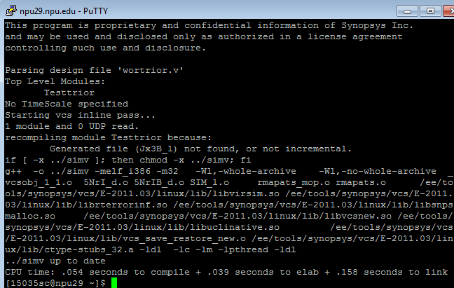

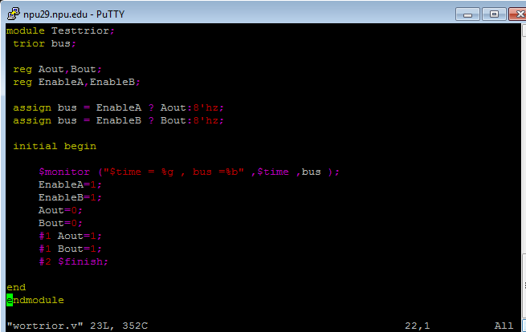

1. Generate variable type “tri0/tri1”, and assign 4 different values (0, 1, X, Z) to observe what you are going to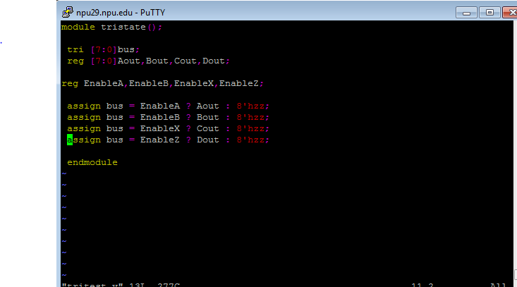

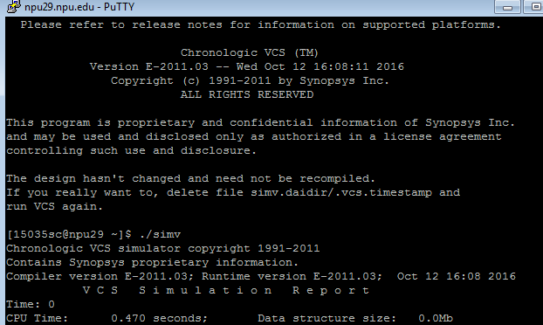

7. Retype “trireg” example code and provide the results.

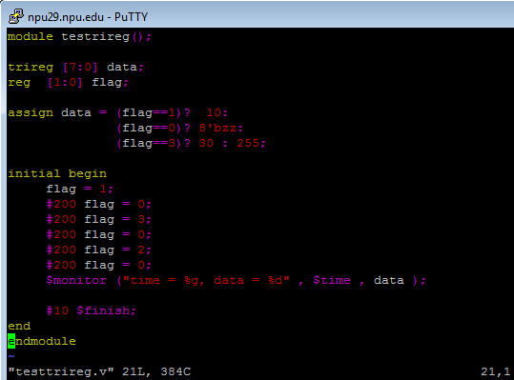

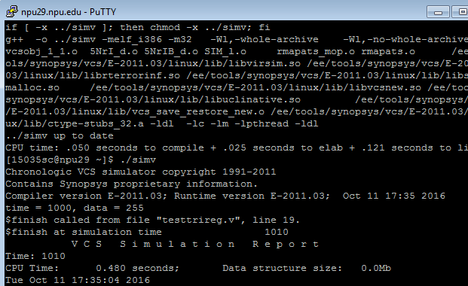

8. Retype “testInteger” program and give the results.

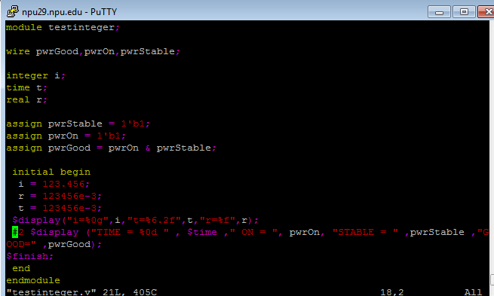

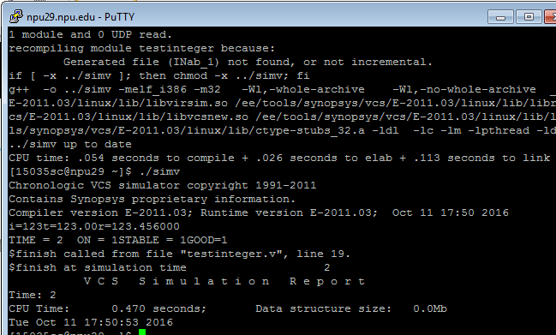

9. Create a “time” variable type and assign it values from $stime and $realtime, what will you get?

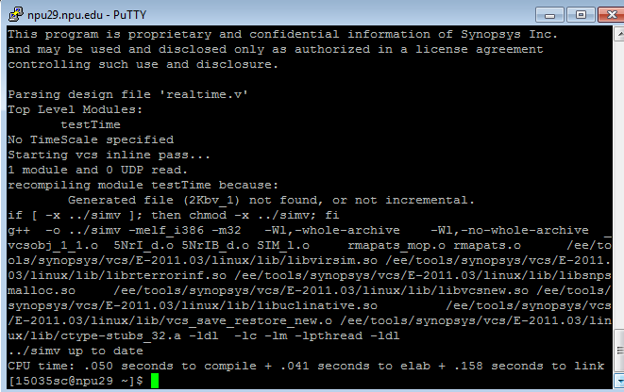

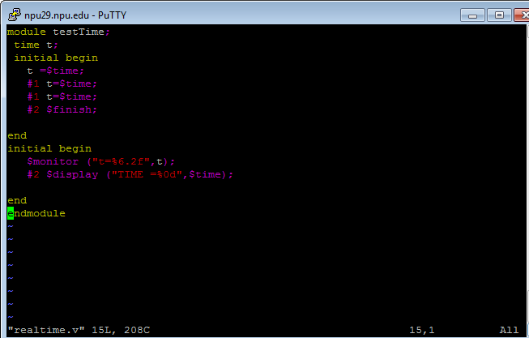

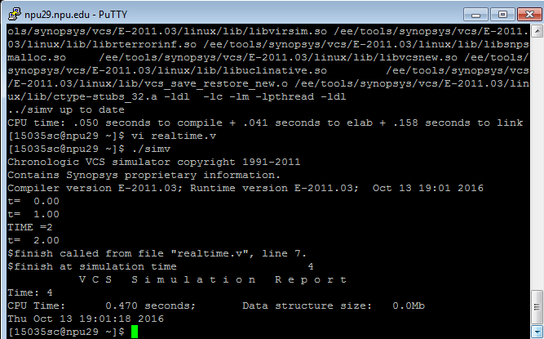

10. Define a time scale like `timescale 10ns/100ps, if a delay is #2.71828, calculate the real delay and compare what the difference between $display result in $time and your calculation is.

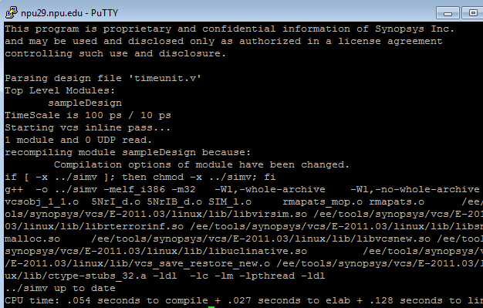

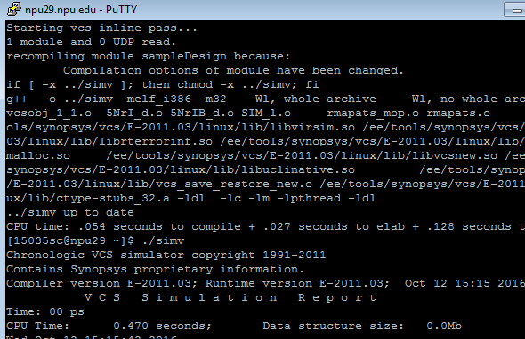

11. Retype “signedNumber” module, and observe the running results.

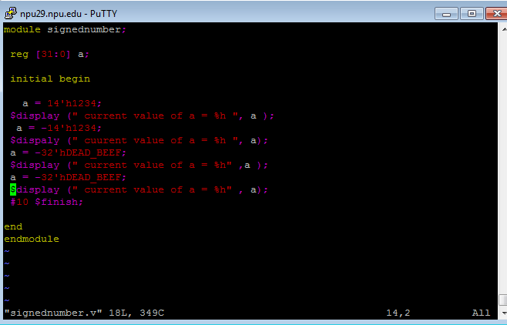

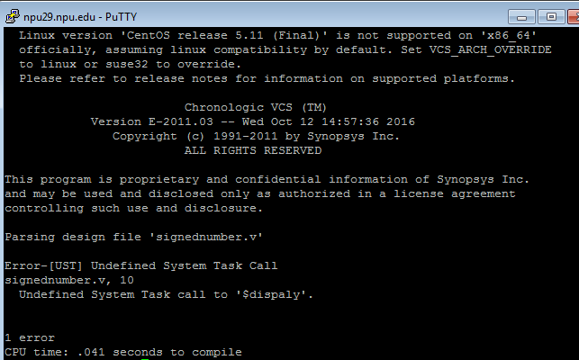

12. Take “helloWorld.v” as an example, write program to print double quote, percent character and @ character in ASCII code number.

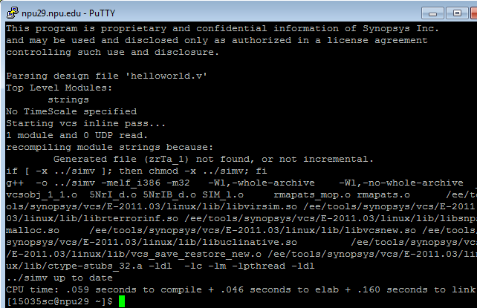

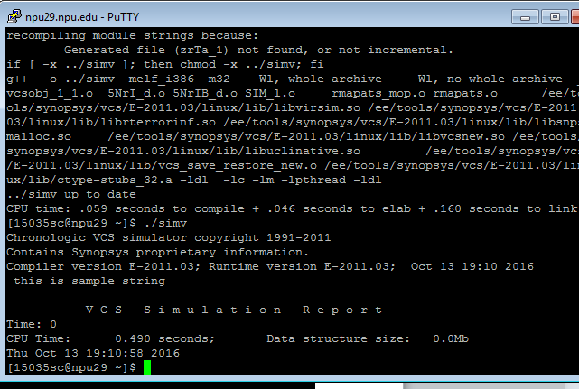

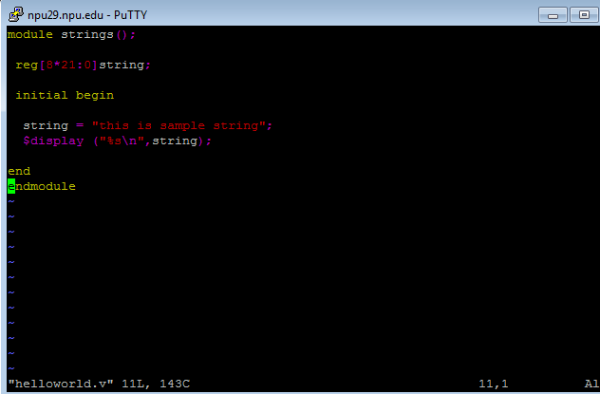

13. Write a program to display values of different variables that could cover format like %b, %c, %d, %0d, %e, %f, %6.2f, %g, %h, %o, %s and %t, %00t.

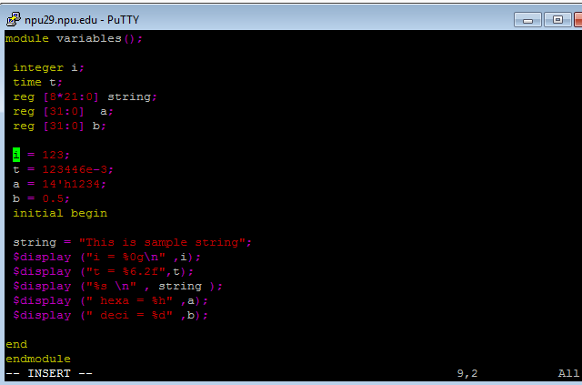

14. Compare $display, $write and $monitor system tasks by a program, and give the running result

